Price Manipulation
Proof of Concept Report — HackViser Lab
Prepared by: Aakash Singh | Date: May 31, 2026

Vulnerability Information

Author | Aakash Singh
Date | May 31, 2026
Lab | Price Manipulation
Platform | HackViser
Vulnerability Type | Business Logic — Client-Side Price Manipulation
Severity | High
CWE | CWE-602
Impact
An attacker can manipulate the ticket price on the client side by intercepting and modifying the HTTP request, purchasing items at an arbitrary price (e.g., 1 currency unit instead of 300).
Reproduction Steps
Step 1: Navigate to the ticket purchase page and select the number of tickets.
Step 2: Enter 11 tickets and proceed to checkout.
Step 3: Enable Burp Suite Intercept to capture the purchase request.
Step 4: Modify the price value in the intercepted request from 300 to 1.
Step 5: Forward the modified request.
Step 6: Select the number of tickets again to confirm the flow.
Step 7: Observe that the purchase completes successfully at the manipulated price.
Evidence Screenshots
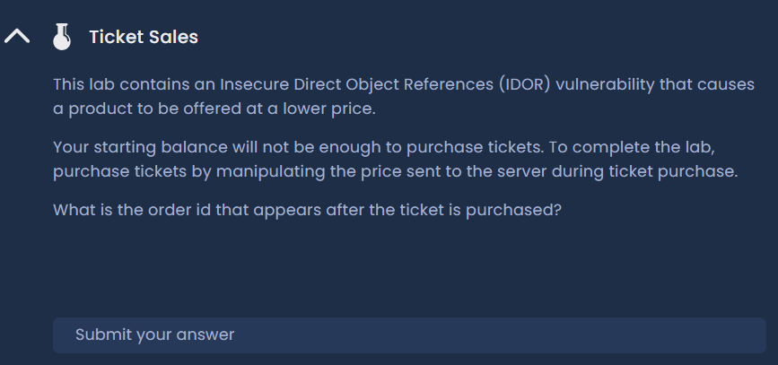
Figure 1: Ticket purchase page — initial state
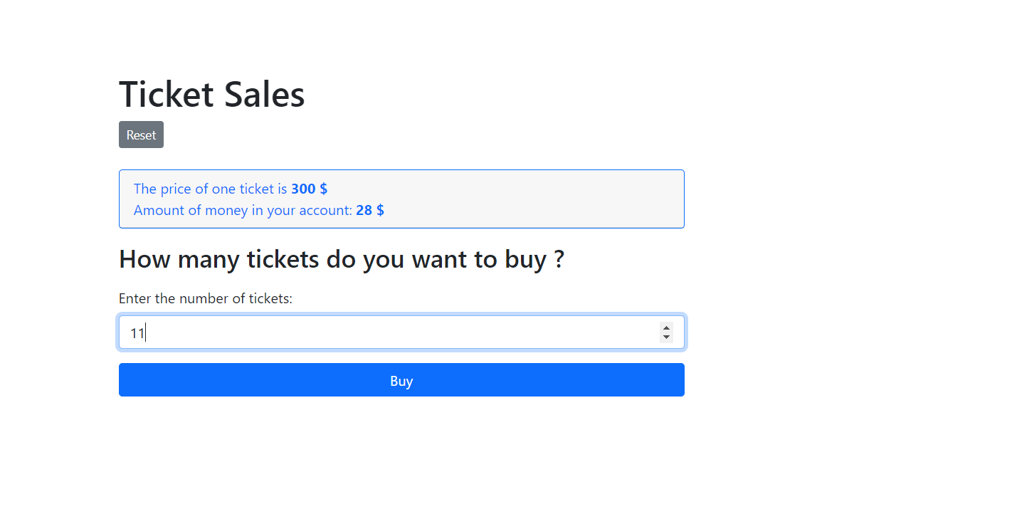
Figure 2: Entering 11 tickets — proceed to checkout
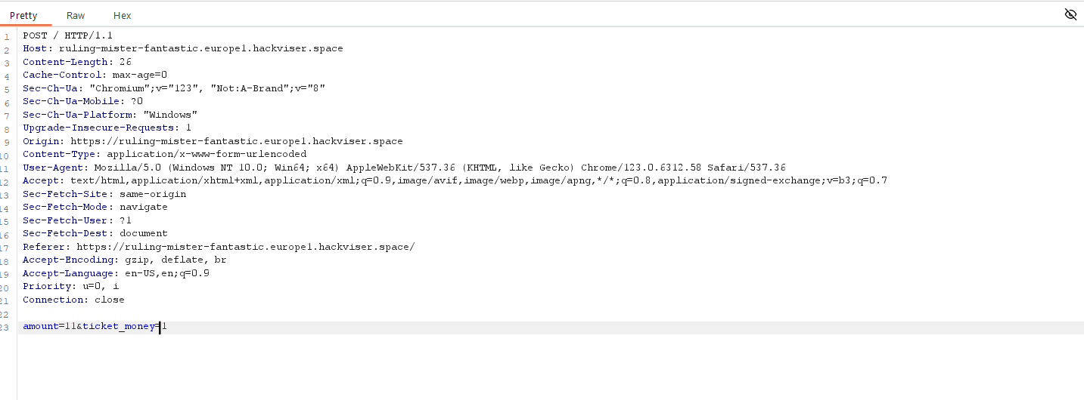
Figure 3: Price manipulation — value changed from 300 to 1 in Burp
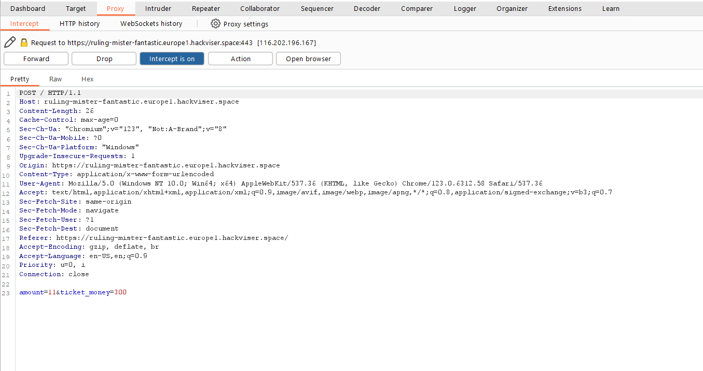
Figure 4: Intercept enabled — request captured
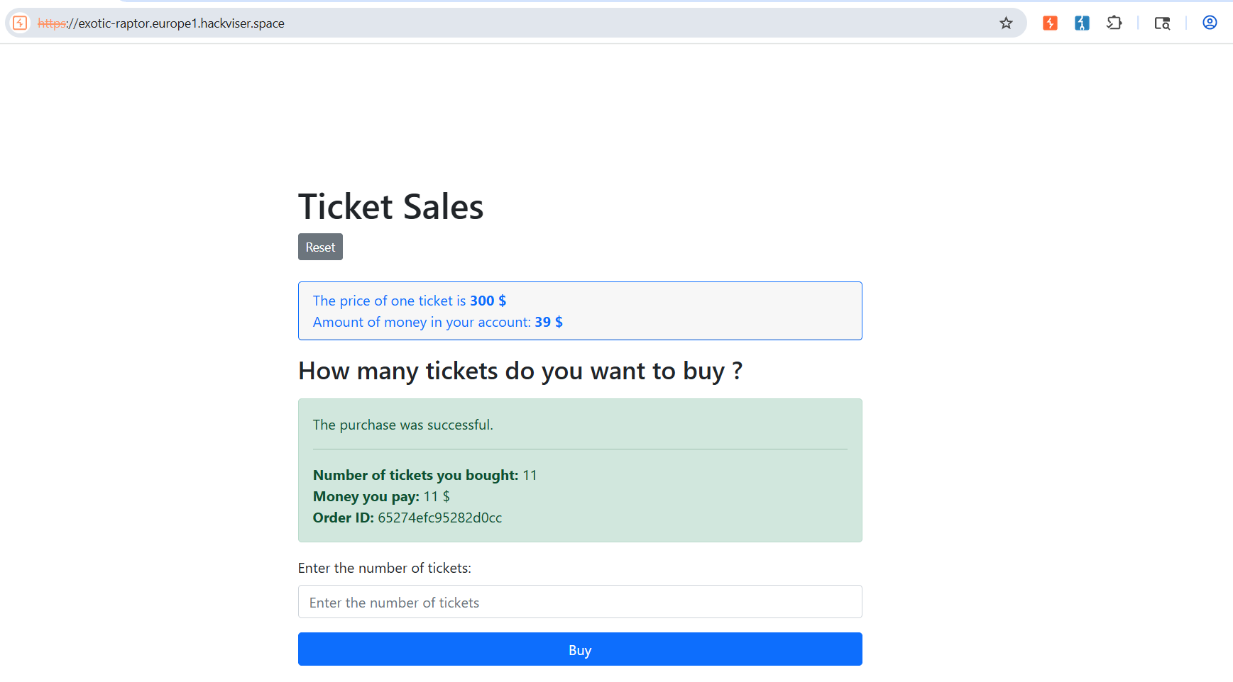
Figure 5: Purchase successful at manipulated price
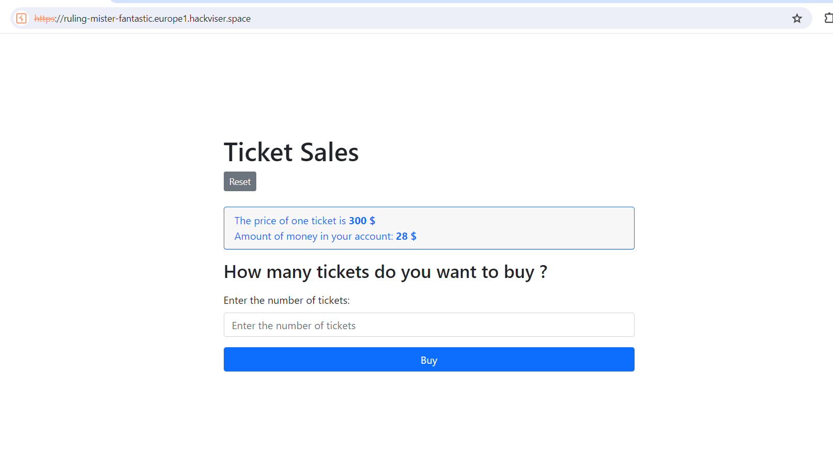
Figure 6: Ticket selection confirmed — lab solved
Remediation
Never trust client-supplied price values. Validate all purchase amounts server-side against the authoritative product pricing database. Reject requests with price parameters that differ from expected values.
Confidential — Prepared by Aakash Singh | Security Research POC

